**Georgia FFA Association**

**Senior Division**

**State Floriculture**

**2013-2014**

**Problem Solving**

**Question 1 - Area**

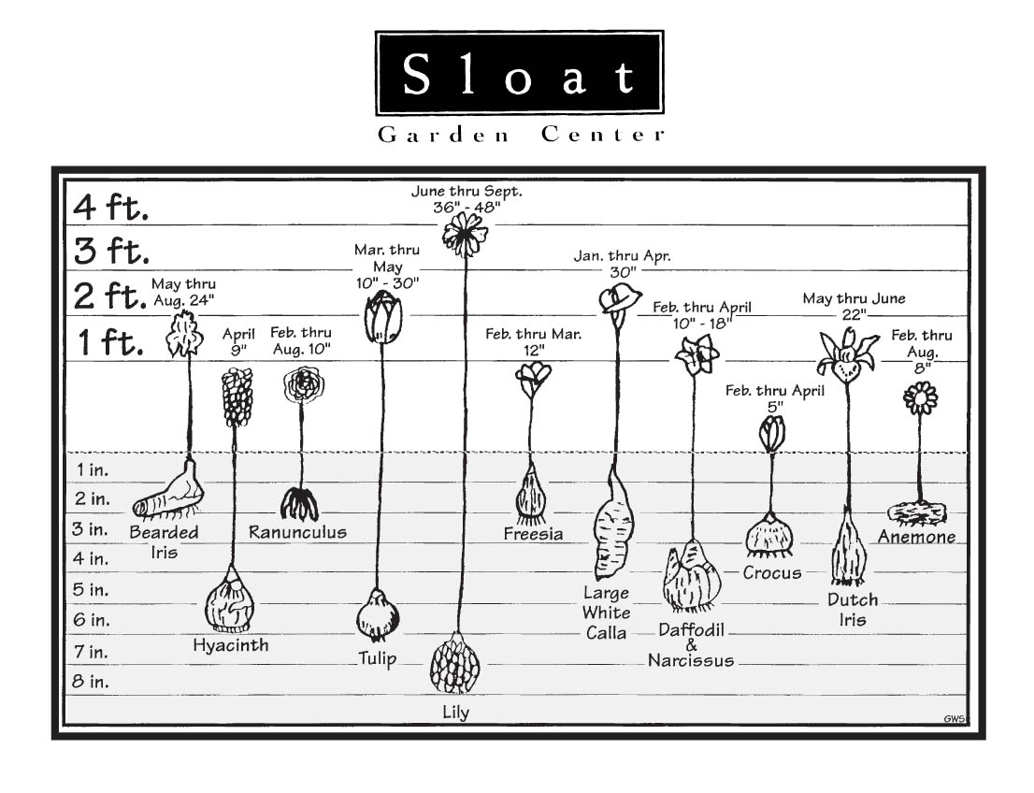

You have been hired to plant a small flower bed in front of the local bank with Hyacinth bulbs. The flower bed measures 4 feet by 2 feet. How many Hyacinth bulbs should be purchased to plant the bed?

*Note: As a general rule, bulbs should be spaced the same distance apart as their planting depth.*

1. 18 bulbs B. 32 bulbs C. 36 bulbs D. 192 bulbs

**Question 2 - Fertilizer**

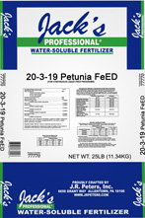

GUARANTEED MINIMUM ANALYSIS:

Total nitrogen (N) ............................................................... 20%

3.1% total nitrogen is water-insoluble nitrogen

5.5% total nitrogen from methylene diurea

1.4% total nitrogen from dimethylene triurea

Available phosphate (P2O5) ................................................ 3%

Soluble potash (K2O) .......................................................... 19%

Sulphur (S) ........................................................................ 7.1%

Thiophanate-methyl (actual) ..............................................1.75%

The recommended broadcast application for a Petunia floriculture crop is:

1st application: Apply 7 pounds of 20-3-19 per 1,000 square feet of bench space

Remaining applications: Apply 3 pounds of 20-3-19 per 1,000 square feet of bench space 14 days after previous application

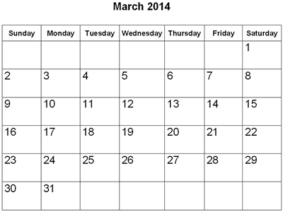

You are responsible for fertilizing your schools greenhouse Petunia

crop for the month of March. You will start your first application on Monday, March 3rd. For a 200’x25’ bench space of the Petunia crop, how many total pounds of fertilizer would you need for the month of March?

1. 15 lbs B. 35 lbs C. 50 lbs D. 65 lbs

Question 3 – Media

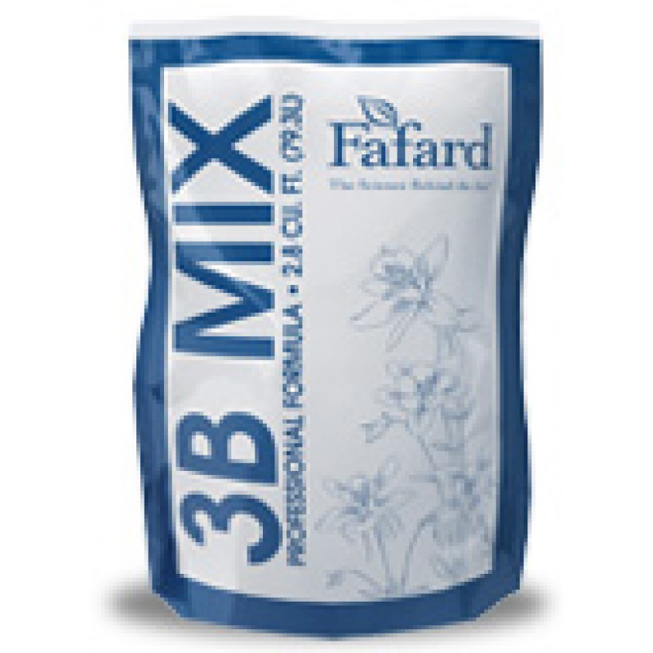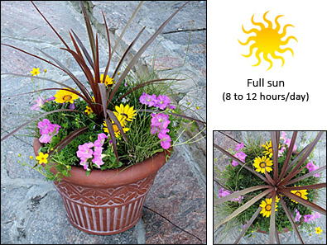

Your horticulture class will be planting mixed containers this spring to sell in your spring plant sale. It takes 1 cubic foot of potting mix to fill each container. Your school uses 2.8 CU FT bags of Fafard 3B Mix. How many bags of potting mix do you need to pot 75 containers?

Note: Round to the nearest whole bag

1. 22 bags B. 25 bags C. 27 bags D. 75 bags

**Question 4 – Pricing**

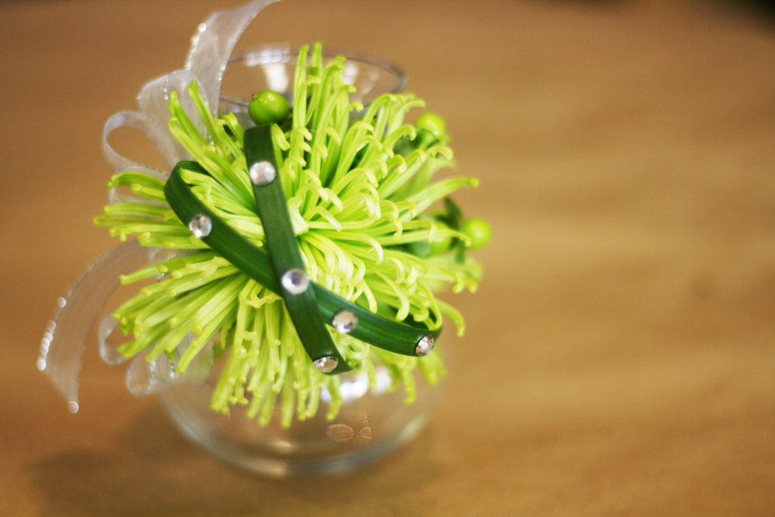

Your horticulture class will be making Fugi Mum corsages to sell during Valentine’s Day. Using the following materials and prices, what would be the selling price of the corsages using a 60% mark up?

1 Fugi Mum $3.99

1 Hypericum Berry $0.92

2 Lily Grass $0.33 each

3 ft Sheer Ribbon $9.99 for 50 ft

10 jewels $3.99 for strip of 25 jewels

**Note: Round up to the nearest whole number**

1. $8.00 B. $12.00 C.$13.00 D. $20.00

**Question 5 – Irrigation**

Due to a water main break in your local city, water restrictions have been placed on a local greenhouse company until a permanent fix can take place. They are only allowed to use 30,000 gallons of water a day. The irrigation system at the greenhouse company consists of 18 mist sprinkler heads that use 3 gallons of water per minute each and 15 impact sprinkler heads that use 5 gallons of water per minute each. How many hours per day could this irrigation system operate using the allotted amount of water?

**Note: Round down to the nearest whole number**

1. 1 hour B. 3 hours C. 5 hours D. 7 hours

**Georgia FFA Association**

**Senior Division**

**State Floriculture**

**2013-2014**

**Problem Solving**

**ANSWERS**

1. B. 32 bulbs

Blubs are planted on 6 inch center leaving 3 inches of space of each side of the bulb

48 inches wide

24 inches deep

48 inches x 24 inches = 1,152 inches2 of bed space

6inches by 6 inches = 36 inches2 of bulb spacing

1,152 / 36 inches = 32 bulbs

1. D. 65 lbs

25 x 200 = 5,000 sq ft of bench space

1st application – March 3rd

Apply 7 lbs of fertilizer / 1,000 sq ft = 35 lbs / 5,000 sq ft

2nd application – March 17th

Apply 3 lbs of fertilizer / 1,000 sq ft = 15 lbs / 5,000 sq ft

3rd application – March 31st

Apply 3 lbs of fertilizer / 1,000 sq ft = 15 lbs / 5,000 sq ft

35+15+15 = 65 total lbs of fertilizer needed

1. C. 27 bags

1 cubic foot / 1 container = 75 cubic feet / 75 containers

75 cubic ft of mix needed / 2.8 mix per bag = 26.786 = 27 bags

1. C. $13.00

$9.99/50 = $0.20 per foot of ribbon

$0.20 x 3 = $0.60 for 3 feet of ribbon

$3.99/25 = $0.16 per jewel

$0.16 x 10 = $1.60 for 10 jewels

$0.33 x 2 = $0.66 for 2 Lily Grass

$3.99 + $0.92 + $0.66 + $0.60 + $1.60 = $7.77

$7.77 x 0.60 = $4.66 mark up

$7.77 + $4.66 = $12.43 = $13.00

1. B. 3 hours

3 gallons per minute x 60 minutes per hour = 180 gallons per hour

5 gallons per minute x 60 minutes per hour = 300 gallons per hour

18 sprinklers x 180gallons = 3,240 gallons per hour

15 sprinklers x 300 gallons = 4,500 gallons per hour

3,240 + 4,500 = 7, 740 gallon per hour total

30,000 gallons / 7,740 = 3.886 hours

3 hours