**Georgia FFA Association**

**Junior Division**

**State Floriculture**

**2013-2014**

**Written Exam**

Directions: Select the best answer for each question and mark your selection on the separate answer sheet provided. On the answer sheet, completely darken the space that corresponds to the best answer for each item.

1. Grafting, cuttings and cloning are all examples of this type of reproduction.

* 1. sexual c. intervention
  2. natural d. asexual

2. A plant that lives for more than two years is a(n) ________.

* 1. annual c. herbennial
  2. perennial d. biennial

3. The main function of leaves is _______________; a process which makes food for the plant using sunlight.

a. transpiration c. hydrosynthesis

b. respiration d. photosynthesis

4. What are the correct percentages of nutrients found in a fertilizer bag labeled 10-20-10?

a. 10% Potassium, 20% Nitrogen, 10% Pot Ash

b. 10% Nitrogen, 20% Lime, 10% Phosphorus

c. 10% Nitrogen, 20% Phosphorus, 10% Potassium

d. 10% Lime, 20% Pot Ash, 10% Fertilizer

5. What part of the plant transports water and nutrients to and from the leaves?

a. root c. bark

b. flower d. stem

6. A(n) ______ is used to control unwanted insects.

a. insecticide c. fungicide

b. herbicide d. mollicide

7. Insects have ______ sets of legs.

a. 3 c. 6

b. 4 d. 8

8. While anchoring the plant, ______ absorb water and minerals from the soil.

a. stems c. fibers

b. roots d. buds

9. _____ is the movement of pollen from one plant to another and is necessary for seeds to form in flowering plants.

a. Pollination c. Propagation

b. Fertilization d. Regeneration

10.Soil texture describes the relative proportion of different [grain sizes](http://en.wikipedia.org/wiki/Particle_size) of [mineral](http://en.wikipedia.org/wiki/Mineral) particles in a soil. Particles are grouped according to their size into what are called soil separates. These separates are typically named _____________.

a. sand, silt, and clay c. adhesion, cohesion, and stability

b. granular, blocky and prismatic. d. organic, inorganic and humus.

11. ___________ (nitrogen, phosphorus, potassium, calcium, magnesium and sulfur) are plant nutrients required in the largest amount in plants.

a. Nutrient substance c. Macronutrients

b. Grand nutriments d. Nutria elements

12. ______ can be added to the soil to make it less acid and also supplies calcium and magnesium for plants to use.

a. Vermiculite c. Sulfur

b. Perlite d. Lime

13. A ______ is a plant that is growing where it is not wanted.

a. weed c. shrub

b. groundcover d. tree

14. If the soil has a low pH it is considered to be _________.

a. alkaline c. neutral

b. acidic d. sandy loam

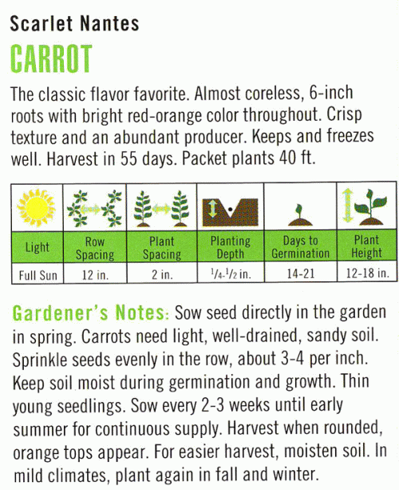Figure 1

15. Using the label in figure 1, where should this plant be located in the garden?

a. partial sun c. no sun

b. partial shade d. full sun

16. A plant that will grow, flower, set seed and complete its life cycle in one growing season.

a. Woody ornamental. c. Annual.

b. Perennial.d. Herbaceous.

17. A plant that is in a resting or non-growing state.

a. Dormant. c. Vegetative.

b. Stoic. d. Deciduous.

18. ____________ are structures within individual plant leaf cells that contain chlorophyll.

a. Stomata c.Stroma

b. Chloroplast d. Cuticle

19. The __________ is made up of all of the sepals on one flower.

a. pedicel c. calyx

b. receptacle d. ovary

20. Roots that begin growth from the stems of the plant are known as

a. adventitious roots. c. tap roots.

b. fibrous roots. d. lateral roots.

21. _________ is a method of growing plants in which the nutrients needed by the plant are supplied by a nutrient solution.

a. tissue culture c. hydroponics

b. cuttings d. grafting

22. The movement of water into the soil is known as

a. eutrophication. c. nitrogen cycle.

b. hydrologic cycle. d. infiltration.

23. Which of the following materials does NOT retain moisture well?

a. Vermiculite c. Peat Moss

b. Sand d. Clay

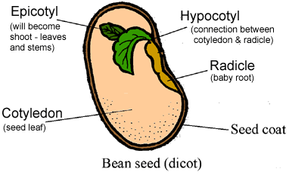 Figure 2

**Part A**

24. The item labeled Part A in Figure 2 above is known as the __________ part of a seed.

a. radicle c. epicotyl

b. hypocotyl d. cotyledons

25. The seed in Figure 2 is an example of a

a. monocot. c. dicot.

b. endosperm. d. pedicel.

**Georgia FFA Association**

**Junior Division**

**State Floriculture**

**2013-2014**

**Written Exam - KEY**

**1. D Introduction to Horticulture – 4th edition – p. 111**

**2. B Introduction to Horticulture – 4th edition – p. 76**

**3. D Introduction to Horticulture – 4th edition – p. 81**

**4. C Introduction to Horticulture – 4th edition – p. 149**

**5. D Introduction to Horticulture – 4th edition – p. 87**

**6. A Introduction to Horticulture – 4th edition – p. 192**

**7. A Introduction to Horticulture – 4th edition – p. 174**

**8. B Introduction to Horticulture – 4th edition – p. 90**

**9. A Introduction to Horticulture – 4th edition – p. 94**

**10. A Introduction to Horticulture – 4th edition – p. 136**

**11. C Introduction to Horticulture – 4th edition – p. 141**

**12. D Introduction to Horticulture – 4th edition – p. 148-9**

**13. A Introduction to Horticulture – 4th edition – p. 180**

**14. B Introduction to Horticulture – 4th edition – p. 147**

**15. D Introduction to Horticulture – 4th edition – p. 106**

**16. C Introduction to Horticulture – 4th edition – p. 75**

**17. A Introduction to Horticulture – 4th edition – p. 75**

**18. B Introduction to Horticulture – 4th edition – p. 77**

**19. C Introduction to Horticulture – 4th edition – p. 93**

**20. A Introduction to Horticulture – 4th edition – p. 92**

**21. C Introduction to Horticulture – 4th edition – p. 133**

**22. D Introduction to Horticulture – 4th edition – p. 59**

**23. B Introduction to Horticulture – 4th edition – p. 117**

**24. B Introduction to Horticulture – 4th edition – p. 98**

**25. C Introduction to Horticulture – 4th edition – p. 98**